HCI-ThermoBank

Brief Introduction

For our design of the ThermoBank, we prioritized accessibility as well portability and functionality. The device will be powered by several thermo pads inside of the bracelet design to allow the heat to transfer from the user’s body to the charging peripheral attached to the bracelet. Those thermo pads help allow the user to receive a decent charge without having to wait a long time to get a charge going. The size of the device will be about 1½ inches and allow the user to stretch the device to fit their wrist more easily without difficulty. The USB port of the product will be placed on top of the bracelet, parallel to the bracelet, making it perpendicular to the user’s arm, to allow the user to have an easier way to charge their phone. This position of the USB port allows for maximum flexibility for the user’s arm without compromising the ability to charge on the move. The main color for the bracelet part of the device will mostly consist of sleek whites to give the device less external heat from the weather and keep the user’s arm cool. This choice in color also allows us to prevent a user’s arm from overheating and cause issues with our product from steam and other water-like substances seeping into the device on accident. The color of the USB port will be a gray color to match the classic style we created with the black bracelet, giving it a sleek visual and look more elegant and practical.

For starters, our logo is symbolizing the idea that we are charging our electronic device from our watch style product. The logo font we used is called Audiowide with a black color(#000000) finish. The accompanying app is designed to be used while on the move, meaning large fonts and easy-to-identify buttons. The imagery used for the app buttons keep a simplistic style to help differentiate themselves from the other buttons much more easily. We kept 2 different font types within the app to help separate their uses. We have the Rockwell font which is mainly used for headings and the main buttons while we keep Times New Roman for the smaller texts to aid users that have trouble reading different fonts that they aren’t used to. The main color palette that we will utilize would be this cool green color(#A0DD9F) to give it a nature vibe that can calm users down as they operate our app. In tandem with this cool green, we kept it simple with a black color(#000000) for any texts and a white color (#FFFFFF) for buttons and the borders of the screen. On the login page, we also have a red color(#FF0D19) that shows a user an error with their password. In order to let users know about certain functions for their community style experience, we included more prominent blue color(#2121FD) to help identify themselves to users that they can be interacted with. By keeping the colors simple, it allows us to keep the design pleasing to the eye without having to overburden the user with complex colors that wouldn’t contribute to the overall product in a productive manner.

All Fonts/Styles/Colors

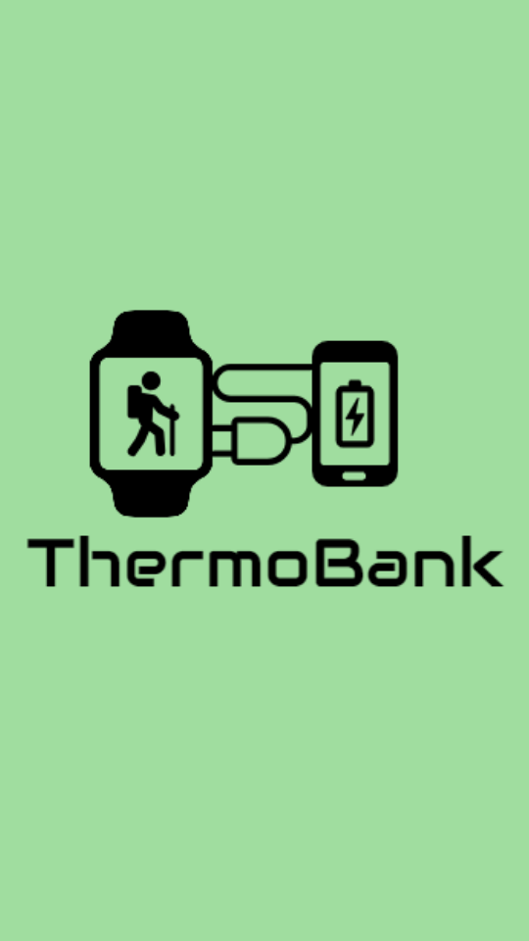

The font used for the logo is Audiowide.

The color number in creating the logo and all text unless specified use is the black code #000000

The color number of the opening page background is #A0DD9F

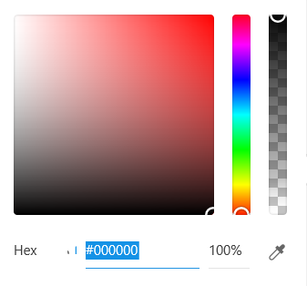 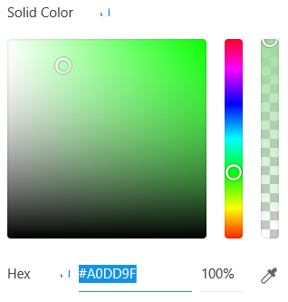

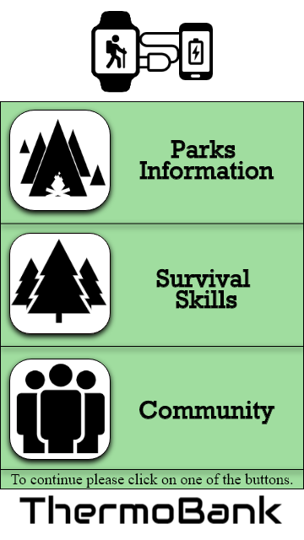

Font of the button words are in bold Rockwell.

The action line “To continue please click…” is in Time New Romans

Color number in creating logo for buttons, background of name company and logo was use white code #FFFFFF

Color number of app background is #A0DD9F and the button background color is #FFFFFF

 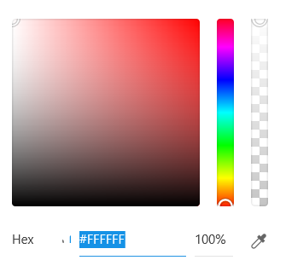

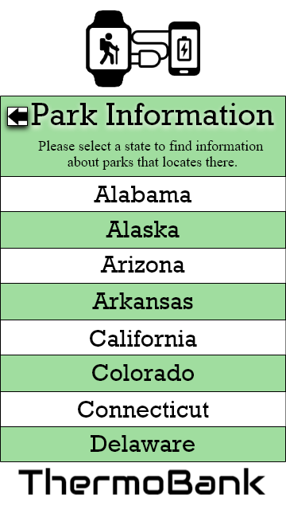

The font of the Heading and State Names are in Rockwell.

The font for the text below the Heading are in Times New Roman

The color number of app background is #A0DD9F and #FFFFFF



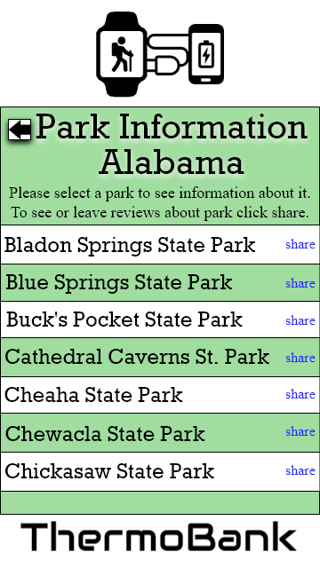

The font for the Heading and the Park Names are in Rockwell.

The share button and text below the heading the font is in Times New Roman

The color number of app background is #A0DD9F and #FFFFFF

The share button color code is #2121FD

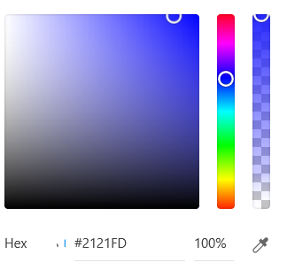

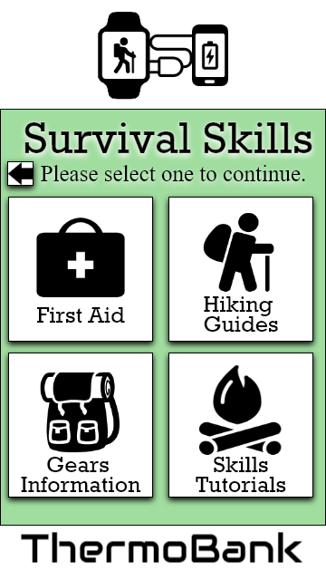

The font of the buttons and heading is in Rockwell.

The font of the words below the heading is in Time New Romans.

The color number of app background is #A0DD9F and the button background color is #FFFFFF



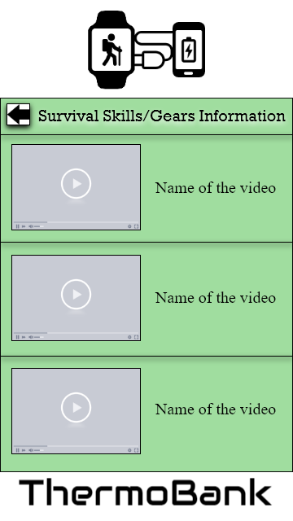

The font of the heading is in Rockwell.

The font of the video titles is in Time New Romans.

The color number of app background is #A0DD9F



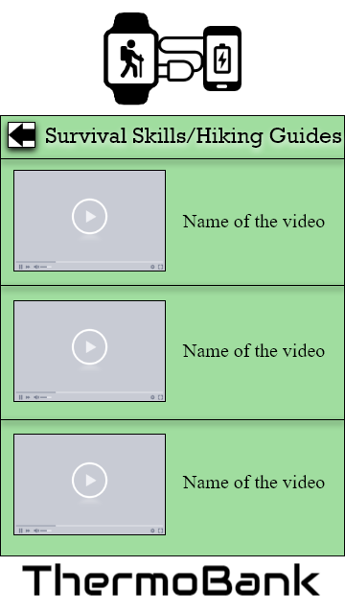

The font of the heading is in Rockwell.

The font of the video titles is in Time New Romans.

The color number of app background is #A0DD9F



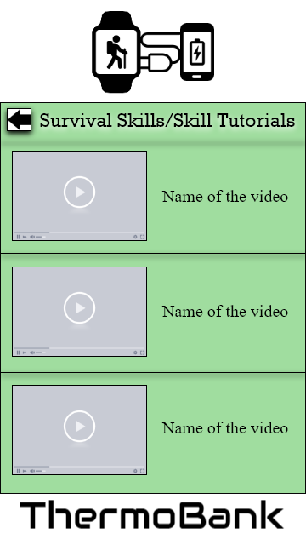

The font of the heading is in Rockwell.

The font of the video titles is in Time New Romans.

The color number of app background is #A0DD9F



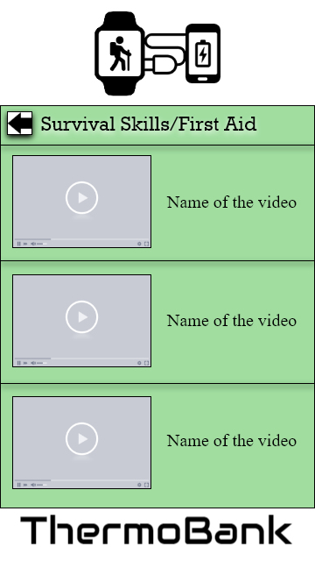

The font of the buttons and heading is in Rockwell.

The font of the video titles is in Time New Romans.

The color number of app background is #A0DD9F



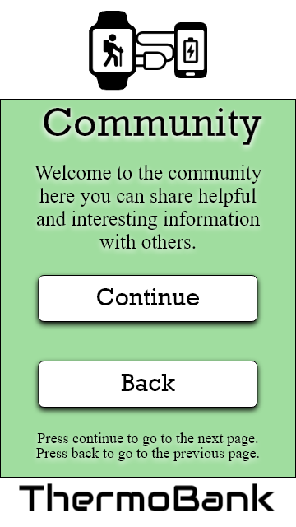

The font of the buttons and heading is in Rockwell.

The font of the words below the heading is in Time New Romans.

The color number of app background is #A0DD9F and the button background color is #FFFFFF



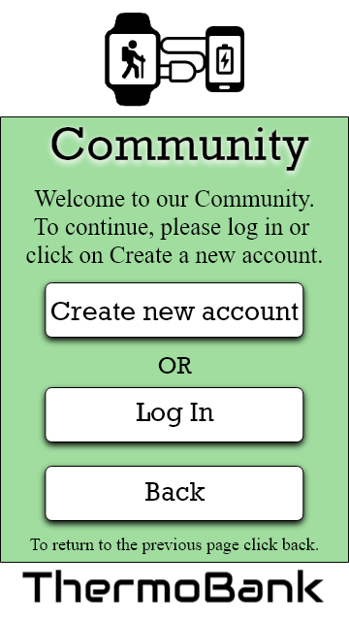

The font of the buttons and heading is in Rockwell.

The font of the words below the heading is in Time New Romans.

The color number of app background is #A0DD9F and the button background color is #FFFFFF



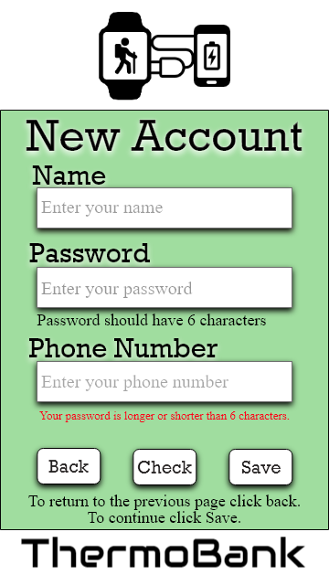

The font of the buttons and heading is in Rockwell.

The font of the words below the heading is in Time New Romans.

The color number of app background is #A0DD9F and the button background color is #FFFFFF

The text error color code is #FF0019

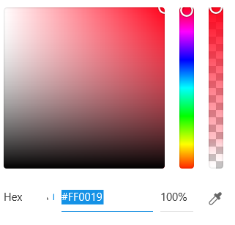

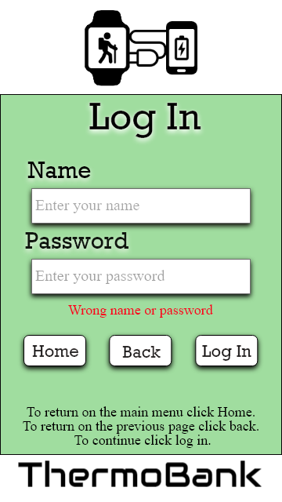

The font of the buttons and heading is in Rockwell.

The font of the words below the heading is in Time New Romans.

The color number of app background is #A0DD9F and the button background color is #FFFFFF

The text error color code is #FF0019



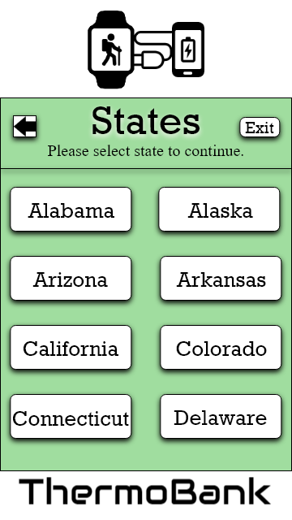

The font of the buttons and heading is in Rockwell.

The font of the words below the heading is in Time New Romans.

The color number of app background is #A0DD9F and the button background color is #FFFFFF



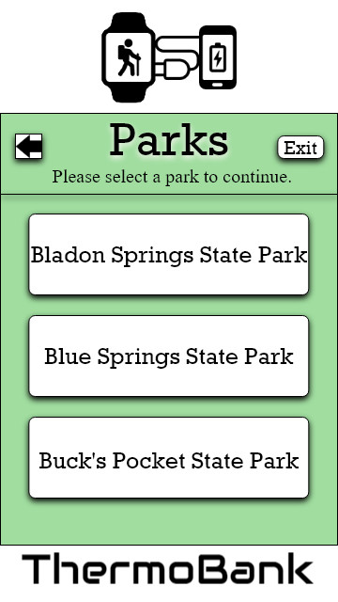

The font of the buttons and heading is in Rockwell.

The font of the words below the heading is in Time New Romans.

The color number of app background is #A0DD9F and the button background color is #FFFFFF



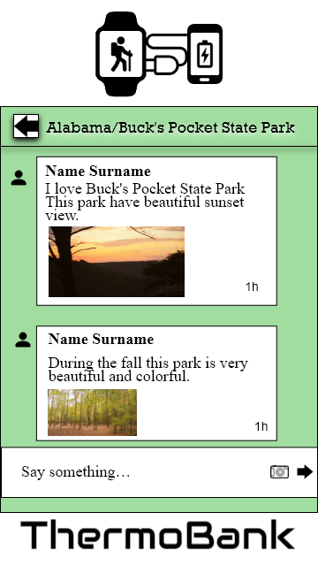

The font of the buttons and heading is in Rockwell.

The font of the words below the heading is in Time New Romans.

The color number of app background is #A0DD9F and the text background color is #FFFFFF



Design of the Bracelet

